Forensic Report
Olutolani Agunloye, Jason Gilson, Lenell Morgan, Raymond Shelton, Steve Leven Song
University of Maryland Global Campus
CYB670 – Capstone in Cybersecurity
Prof. Debora A. Plunkett
November 10, 2021

Table of Contents
Forensic Report 3
Full Packet Capture Analysis 3
Industry Standards and Tools 5
Recommendation 5
References 7
Appendix A 8
Lab Analysis 8

Forensic Report
This forensic report has been prepared in the course of our investigation into the potential cyber incident involving multiple workstations on the government network. The digital forensic Team conducted a detailed analysis utilizing the full packet capture files containing the encapsulated data of internal and external network packets. Various reports from users were submitted regarding web browser errors indicating access issues such as, “404 error – Page Not Found”.

Full Packet Capture Analysis
Forensic examiners utilized the open source Wireshark packet capture tool to analysis a subset of the internal and external network traffic. The full packet capture contained various data packet information including source and destination Internet Protocol (IP) addresses, packet sequence numbers, service type, and payload. The data presented within the packets were utilized to determine the source of the attack, methods of intrusion, and any other elements used during the incident.
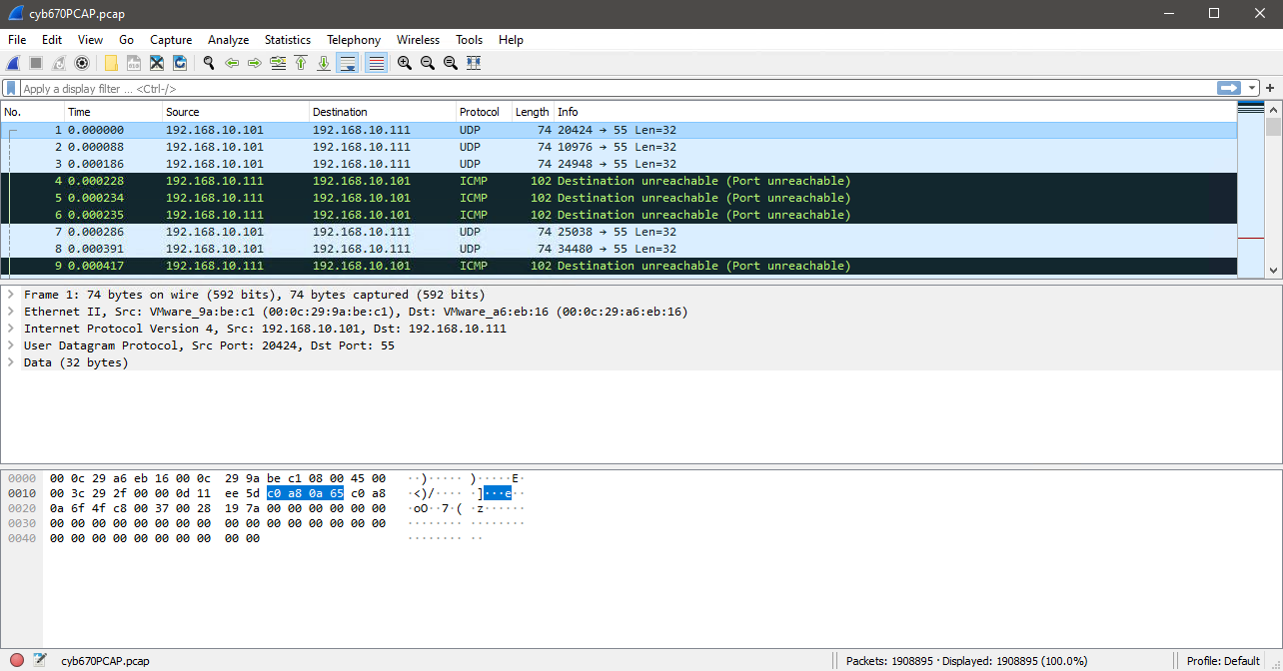
Figure 1 (UMGC Lab, 2021)

Figure 2 below provides a list of relevant IP addresses that were contained within the full package capture file. The examiner identified three hosts relating to possible threat vectors, which included IP address 192.168.10.101, 192.168.10.111, and 192.1683.10.112. Analysis of the IP addresses revealed the hostnames and MAC addresses listed in Figure 3.
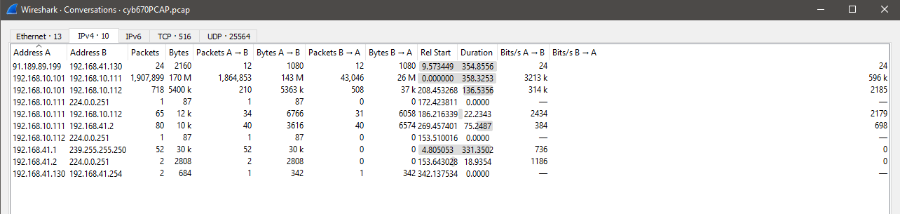
Figure 2 (UMGC Lab, 2021)

IP Address | Hostname | MAC Address
192.168.10.101 | NIXATK01 | 00:0c:29:9a:be:c1
192.168.10.111 | NIXTGT01 | 00:0c:29:a6:eb:16
192.168.10.112 | NIXTGT02 | 00:0c:29:f4:01:46
Figure 3 (Host Information)

Further review of Figure 2, examiners determined that the host address, 192.168.10.101, was transmitting 170 Million Bytes of traffic to host address, 192.168.10.111. Figure 4 shows the parsed information of the type of network traffic between the two affected hosts. Large amounts of traffic was sent using the User Datagram Protocol (UDP) on Port 55.
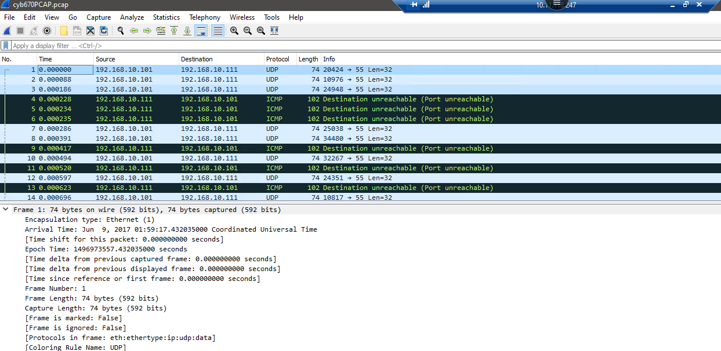
Figure 4 (UMGC Lab, 2021)

Industry Standards and Tools
Tools | OS Platform | Capabilities | Costs
Wireshark | Multiple | Open-source, software and communications protocol analyzer | Free
Suricata | Multiple | Open-source, protocol analyzer, logging, IDP/IPS capabilities, integrated to Splunk | Free
Snort | Multiple | Open-source, protocol analyzer, logging, IDP/IPS capabilities, industry standard on commercial IDS/IPS | Free
Solarwind | Multiple | Protocol analyzer, logging, usability, visual representation | $1750 Annually
Tcpdump | Multiple | Packet analyzer, logging, basic | Free
Figure 5 (Analysis Tool Comparison)

Recommendation
Based on the current analysis of threats, vulnerabilities, and network infrastructure, it is recommended that the organization implement an intrusion detection system (IDS) at the enclave boundary and internal boundary to capture traffic traversing into and out of the organizational network. Intrusion detection and prevention systems provide an all-inclusive packet capture capability compatible with various protocol analyzers. Most IDS/IPS provides an integrated correlation engine to that programmatically aggregate, normalize and analyze logs, which ultimately enables higher fidelity into a cyber incident (McAfee, 2021). The organization can incorporate signature based alerting capabilities to maintain near real-time situational awareness to integrate into the incident response process. The availability of validated indicator of compromise can minimize the reaction time required to address or mitigate a potential threat.

References
McAfee. (2021). McAfee Advanced Correlation Engine. https://www.mcafee.com/enterprise/en-us/assets/data-sheets/ds-advanced-correlation-engine.pdf

Appendix A

Lab Analysis
The figure above will be used to answer the question below. How many packets were sent in the total conversation, and from each computer?
Total: 1,907,899
Computer A: 192.168.10.101 = 1,864,853
Computer B: 192.168.10.11 = 43,046

How many bytes were sent in the total conversation, and from each computer?
Total: 170 M
Computer A: 143 M
Computer B: 26 M
- How long (duration) was the conversation?
From the conversation table located in Wireshark the duration was 358.3253 seconds. Which equal out to 5.97 minutes.
In reviewing the initial packet capture, answer the following questions:
- What time did this incident begin?
The first packet arrived Jun 9, 2017 01:59:17.43205000
- What protocol is being used?
The protocol that’s be used is IPv4
- What destination port is being affected?
The port that’s being affected is port 55
- What is the IP address of the affected system?
The affected system is 192.168.10.101
- What is the total number of bytes of the data in the packet?
It appears to be 74 bytes in each packet sent.
- Which protocol is being used for the host monitoring system that alerted the system administrator to this incident?
From during a packet analysis, I have determined that the protocol that’s the monitoring system is using is User Datagram Protocol.

Based on the UDP data transfer between two IP stations or endpoints (i.e., source and destination IPs), identify the state of affairs of the UDP packet.
- How many fields are there in the UDP packet and what are they? List them.
There are only four parts to a UDP packet that is source port, destination port, length and checksum.
- Why do you think the Checksum status is not verified?
The TCP checksum will only be tested for packets that have been fully captured, and thus for short packets, the checksum will not be verified. But then again, short packets will be ignored by the desegmentation engine anyway.
- What accounts for the hexadecimal value of the UPD packet in the packet byte or status pane?
What are these values in decimals?

- What time did this incident end? What was the total time this incident occurred (in seconds or minutes)? The attack ended at June 9, 2017 at 02:05:15

Use your analysis and findings to help answer the following questions for the HTTP traffic directed at the internal web server:
- Was the web server under some sort of an attack, and if so, what type(s)?
It is unclear at the moment as to what particular cyber-attack the server is experiencing, but from the packet analysis it appears to either be a Brute force or denial of service.
- Was the attack(s) successful in any way (if any)?
From the amount of request that was sent to the system It was successful in a way. It doesn’t appear that the malicious was able to gather access to the back end of the server (Brute force), but have been able to slow down the available of the server to users (Denial of service). It
- What next steps can be recommended for further investigation?
To research the IP address causing the denial of service or the brute force attack and create and an attribution report.
- What is the name of the resource that is being requested in the GET request?
The resource that receiving the GET request is Wordpress.
- What is the server's HTTP response code, and what is the IP of the requesting computer?
The IP address that’s requesting the GET request is 192.168.10.111 and the responses that the server is replying is 404 Not found and 403 Forbidden
- What is the user-agent string for this request?The user string is User-Agent: Mozilla/4.0 (compatible; MSIE 6.0; Windows NT 5.1)What HTTP response code is returned for each abnormal request, and what URL is attempted to be used as part of one of the web attacks?http://192.168.10.111/wordpress/moadmin/moadmin.php

